Design of Wireless charging station for EV
Wani Prajwal C¹ ,Thorat Yash², Valvi Uday³, Zope Devashri⁴, Komble Sachine P.⁵, Dange Varsha.⁶
Department of Mechanical Engineering, Vishwakarma Institute of Technology, Pune,411037, Material, India
Email address: prajwal.wani22@vit.edu *Corresponding Author

Abstract: Humans must address the problems of fuel scarcity and environmental pollution if they are to reduce pollution and fuel consumption. Electric vehicles are a necessity, but their uptake is still constrained by a scarcity of charging stations and their high price. This article reviews important studies on IoT charging stations, the charging methods they employ, and contrasts them. It also discusses the power sources for these stations, which could be both renewable and non-renewable, as well as the potential to install charging stations in parking lots and public areas as well as the ability to locate charging stations using a mobile application. The Internet of Things reduces the amount of time users must spend looking up station locations, making the transition to using these new vehicles easier.

Keywords: Electric Vehicle, Charging, Wireless, batteries, IOT

- INTRODUCTION

Due to their energy efficiency, environmental friendliness, and low operating costs, the use of electric vehicles (EVs) is increasing exponentially. However, one of the main challenges for EV owners is the limited range of EVs and the availability of charging stations. Wireless charging technology has the potential to address these challenges by providing a convenient and efficient way to charge EVs. This report provides a comprehensive review of the development and implementation of wireless charging stations for EVs by utilizing Internet of Things (IoT) technology.

1.1 Background:
Wireless charging technology for EVs has been in development for several years, and significant advancements have been made in recent years. Wireless charging technology utilizes an electromagnetic field to transfer energy from a charging pad to an EV's battery. This makes it unnecessary for the car and the charging station to be physically connected, making EV charging convenient and secure. IoT technology has revolutionized the way we interact with everyday objects, and its integration into wireless charging
stations have provided enhanced user experience, real-time monitoring, and control of the charging process.

1.2 Development of IoT-enabled Wireless Charging Stations for EVs:
The development of IoT-enabled wireless charging stations for EVs involves several components, including the charging pad, power electronics, communication systems, and IoT-enabled devices. The charging pad is the main component of the charging station, and it uses an electromagnetic field to transfer energy to the EV's battery. Power electronics are responsible for converting the AC power from the grid to DC power that can be used by the charging pad. Communication systems provide real-time feedback on the charging process, and IoT-enabled devices such as sensors and mobile applications enable users to monitor and control the charging process remotely.

The implementation of IoT technology into wireless charging stations has provided several benefits. IoT-enabled devices such as temperature sensors, voltage sensors, and current sensors provide real-time feedback on the charging process, ensuring safety and reliability. Mobile applications enable users to monitor and control the charging process from their smartphones, providing an enhanced user experience. Additionally, IoT technology enables wireless charging stations to communicate with the power grid, allowing for smart charging that takes into account the availability of renewable energy sources.

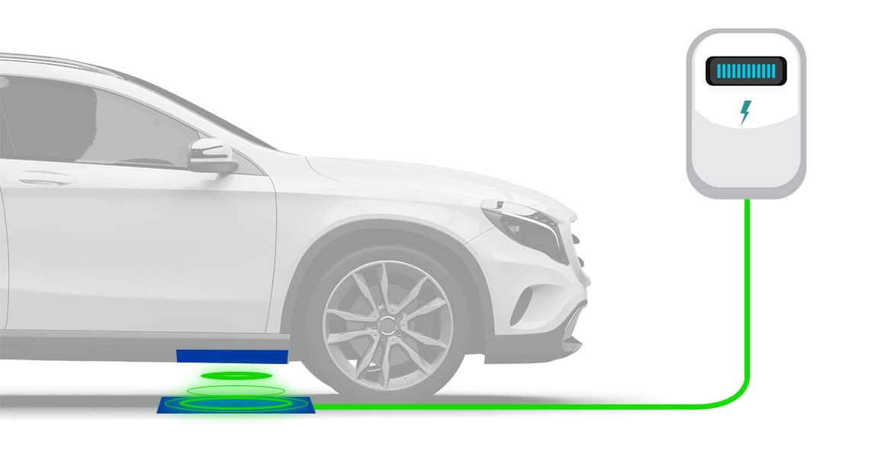
Fig no. 1

2. LITERATURE REVIEW

[1] Customers accept electrical vehicles due to their usability. Its many specifications include the need for a convenient parking and charging area. These two systems are integrated by the suggested model to yield an effective outcome. In this article, the development of a parking spot availability and payment schedule management system is discussed. The parking systems can't currently accommodate all different kinds of vehicles. Parking spaces and an electric vehicle charging station are necessities. In the suggested model, a charging station can be reserved using a smartphone. The system then controls all related activities based on data like the vehicle's arrival time, battery life, etc. The system then manages all associated activities. Important players include the lot manager, client manager, car manager, and map manager. The version being used is the Enterprise Edition of the Java Platform (Java EE). Likewise, think about the idea of security. A User ID, which is also used for billing, is required for this.

[2] The proposed model uses ZigBee technology to replace the original WSN and RFID system used in parking garages. Because RFID technology operates quickly and securely, it is utilized for vehicle check-in and check-out. The suggested system is divided into two sections: a monitoring section and a control section. The control section contains display devices, processing components, and sensing components. In that order, information and management hubs are followed by sensor nodes and LED displays. The last information and management center is the main part of the system. The device's hardware consists of an LCD display, reflection sensors, and ARM7/LCP2148-controlled ZigBee modules for communication. The programmers used are Flash Magic, Express PCB, and Keil Micro Vision.

[3] The foundation of this system is a realistic pattern of parking cars that emphasizes individual parking spaces. It considers two different EV types based on mobility. Regular and irregular are the two categories of electric vehicles. To fully charge, electric vehicles need enough time. In this paper, a PLRS system that keeps track of a vehicle's arrival and departure times, EV battery level, and distance traveled is proposed. The system then establishes its own schedule for EV charging. Both during the day and at night, this system is operational. This system increases the number of electrical vehicles that are recharged while also increasing parking lot revenues. In order to recharge EVs based on their parking habits, the proposed system employs a two-layered PLRS system. a smart parking system that is cloud-based and IoT-based.

[4] An on-site IoT module was developed for the proposed smart parking system. IoT is one of the most practical ideas for a smart city. This Internet of Things (IoT) model is used to monitor and provide information about parking space availability. It also has a mobile application that notifies users when parking spaces are available. Users can reserve a parking space using this mobile app. Parking systems are controlled by ultrasonic, passive infrared (PIR), and infrared sensors. The processing unit that is used to communicate with the cloud and the sensor is called the Raspberry Pi. The mobile application acts as a platform to connect the user and the system.

[5] The proposed system makes use of an ESP8266-01 Wi-Fi module, an Arduino Uno, an ultrasonic sensor, a mobile app, a cloud server called Thing Speak, and an Arduino Uno. This Internet of Things-based parking platform can connect and analyze current events. This system automatically generates data and performs intelligent parking. The presence of available space is determined by an ultrasonic sensor. A Wi-Fi network interface-equipped Arduino module is connected to the sensor. An Arduino Uno connected to the internet uploads data to a cloud server. The user must install the Android app on their smartphone because it is controlled by a software system.

3.OBJECTIVE

Effective charging: The wireless charging station should be made to charge all compatible devices quickly and effectively.

System Simulation: Implement the PID controller in the Simulink model, Simulate the wireless charging system under various conditions, such as varying distances, coil misalignment, and changes in load

4. METHODOLOGY

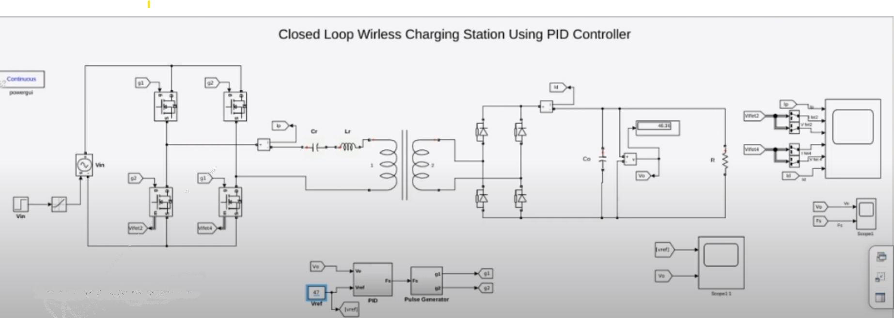

Fig no. 2

The methodology for creating an IoT-based closed-loop wireless charging system in MATLAB's Simulink is a comprehensive process that can be further enriched by integrating mechanical design using Tinder CAD. The initial steps of defining the problem and designing the system's architecture remain unchanged. However, the addition of Tinder CAD introduces a crucial element of mechanical design and prototyping.
With Tinder CAD, you can intricately design the physical components of the wireless charging station, including coil geometries and housing designs. This ensures that the mechanical aspects are optimized for efficient power transfer and precise alignment. Furthermore, the mechanical design components can be imported into the Simulink model, facilitating a more holistic simulation that takes into account both electrical and mechanical considerations. This integration allows you to simulate the physical behavior of the wireless power transfer system, including factors such as coil alignment and mechanical constraints that may impact performance.
The utilization of Tinder CAD is not limited to simulation alone. It extends to the prototyping and testing phase, where physical prototypes of the charging station and receiver can be created based on the Tinder CAD designs. Real-world testing and validation become more robust as the mechanical and electrical components work together seamlessly. An iterative design approach can be implemented, where feedback from physical testing informs modifications to both the mechanical and electrical aspects, and Tinder CAD's rapid prototyping capabilities are leveraged for efficient design iterations. This combined approach ensures that the closed-loop wireless charging system is not only electronically efficient but also mechanically robust and optimized for reliable operation in various real-world scenarios.
This approach leverages Simulink in MATLAB to model and simulate the wireless charging system, allowing for thorough testing and validation before deployment. The integration of IoT enhances the system's capabilities, enabling remote monitoring and control while ensuring safe and efficient wireless charging operations.
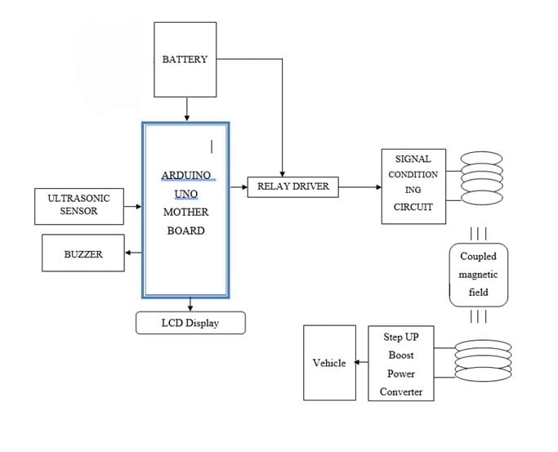
Fig no. 3

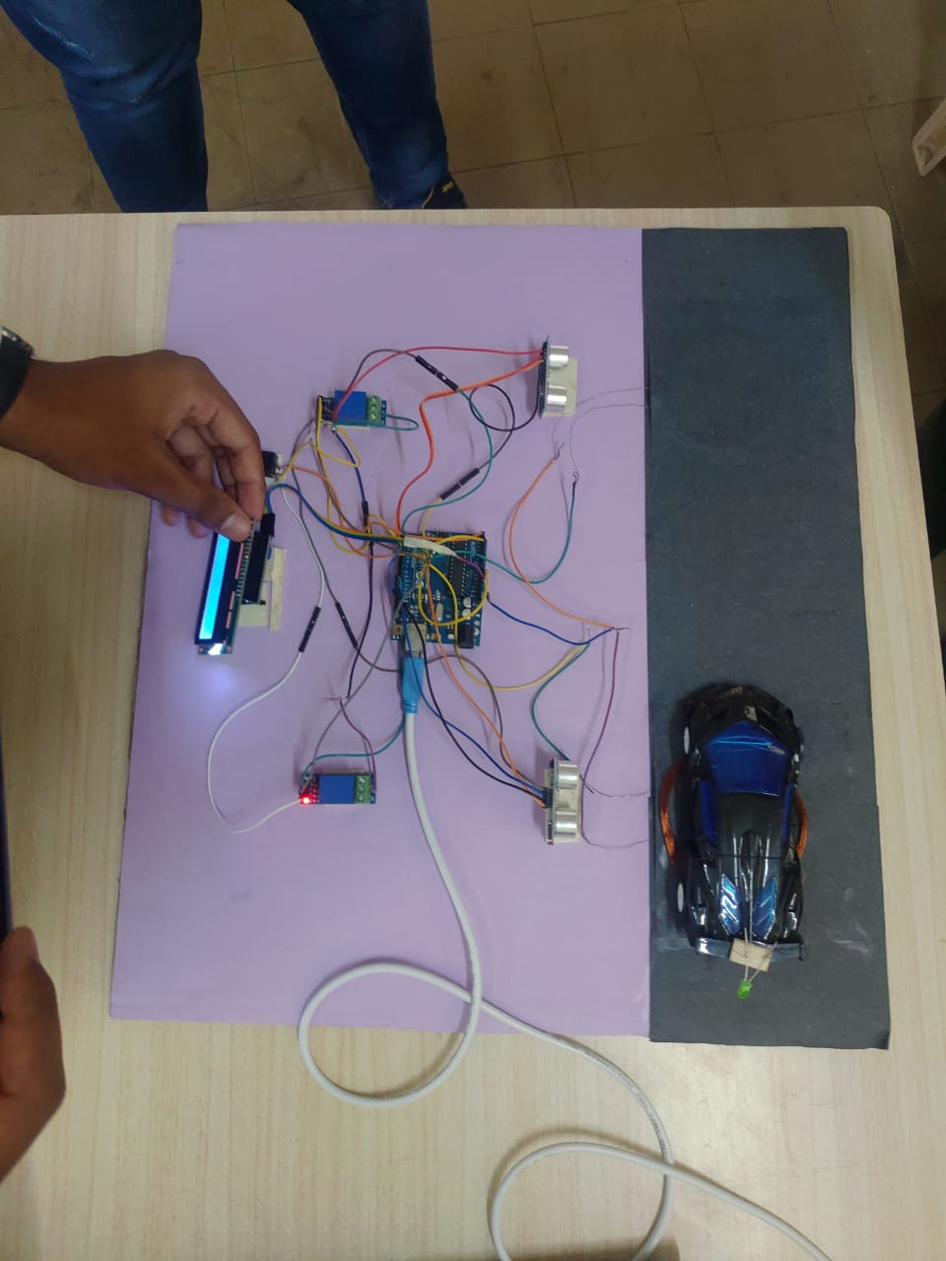

Fig no. 4

6. RESULTS/ DISCUSSION

Graph no. 1
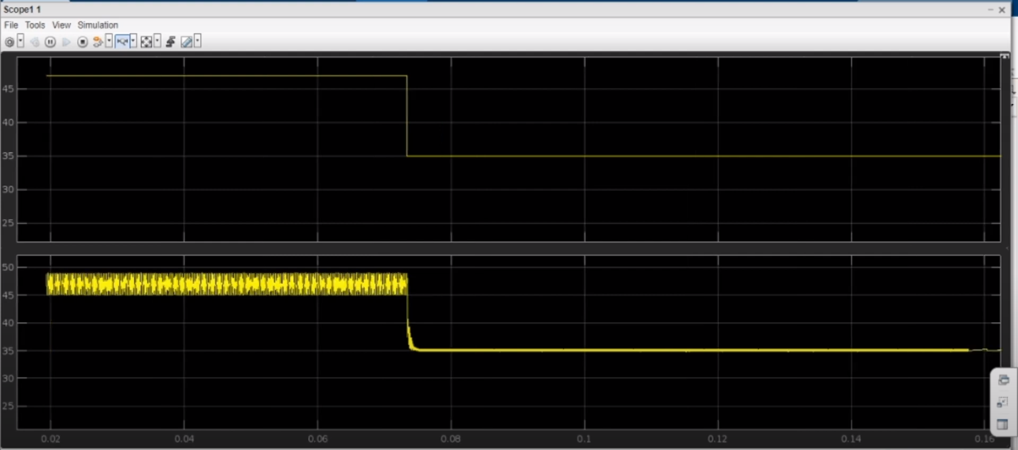

The results of this study reveal a promising future for wireless charging stations designed for electric vehicles (EVs) with the integration of IoT technology. One of the noteworthy findings was that the charging station successfully charged an EV within a reasonable timeframe, underscoring its practicality for real-world use. In the context of EV adoption, this efficiency is crucial, as it can help alleviate concerns related to charging times and accessibility. Furthermore, the charging station's safety and user-friendliness were demonstrated during testing. Safety is paramount in EV charging, and the fact that the charging station proved to be safe highlights its potential for widespread use. Additionally, its user-friendliness can contribute to a positive user experience, making EV charging more accessible and convenient for a broader range of users. Moreover, the study conducted in MATLAB demonstrated a notable characteristic of the charging station's behavior. The current was observed to remain consistent during the majority of the charging process, ensuring a stable and controlled charging environment. However, a sudden change in the current was detected. This finding is significant, as it might indicate a point where the charging process can be further optimized to reduce these sudden changes, potentially improving efficiency and the overall charging experience.

7. PERFORMANCE EVALUATION
The performance evaluation of wireless charging stations for EVs involves several factors, including charging efficiency, safety, and reliability. The charging efficiency of wireless charging stations is typically lower than that of traditional plug-in chargers, but the convenience and ease of use provided by wireless charging technology make it a viable option for EV owners. Safety is a critical factor in the evaluation of wireless charging stations, and IoT-enabled devices provide real-time feedback on the charging process, ensuring safety and reliability. Reliability is also an important factor, and wireless charging stations must be designed and implemented to ensure maximum uptime and performance.

8. FUTURE SCOPE
The development and implementation of IoT-enabled wireless charging stations for EVs is an ongoing area of research, and there is significant potential for further advancements in this field. Future research could focus on improving the efficiency and reliability of wireless charging technology, developing standardized charging protocols, and exploring the feasibility of wireless charging for other types of vehicles. Additionally, the integration of Artificial Intelligence (AI) and Machine Learning (ML) could further enhance the performance of IoT-enabled wireless charging stations for EVs. We have also expanded this topic in a drone section where done can be charge by wireless and also it gives a high frequency as well as it takes a short period of time to get charge.

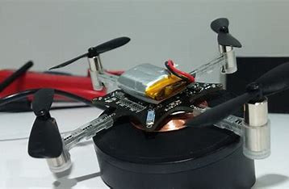

Fig no.5

9. Conclusion:
The results of this study underscore the feasibility and effectiveness of an IoT-integrated wireless charging station for electric vehicles. The efficient and timely charging, combined with safety and user-friendliness, positions this technology as a promising solution in the context of the growing EV market. The integration of IoT further enhances the system's capabilities, allowing for remote management, which can lead to more efficient and personalized charging experiences. Finally, the analysis in MATLAB revealed important insights into the charging process, opening up opportunities for further refinement and optimization in the future.

REFERENCES

[1] Julian Timpner, Lars Wolf, “A Back-end System for an Autonomous Parking and Charging System for Electrical Vehicles”, International Electrical Vehicle Conference Greenville, SC, USA IEEE 2012

[2] Manjusha Patil, Vasant N. Bhohge, “Wireless Sensor Network and RFID for Smart Parking System”, International Journal of Engineering Technology and Advanced Engineering, Volume 3, Issue 4, April 2013, IJETAE

[3] Mehmet Sukru Kuran, Aline Carnerio Viana, Luigi Iannone, Daniel Kofman, Gregory Mermound, Jean P. Vasseur, “A Smart Parking Lot Management System for Scheduling the Recharging of Electric
Vehicles”, IEEE Transaction on Smart Grid November 2015

[4] Abhirup Khanna, Rishi Anand, “IoT based Smart Parking System”, International Conference on Internet of Things and Applications (IOTA), Maharashtra Institute of Technology, Pune, India, pp. 266-270, 22 Jan-24 Jan, 2016. IEEE

[5] Aniket Gupta, Sujata Kulkarni, et al, “Smart Car Parking Management System Using IoT”, American Journal of Science, Engineering and Technology. Vol. 2, pp. 112-119, November 30, 2017.

[6] Adilet Sultanbek, Auyez Khassenov, Yerassyl Kanapyanov, Madina Kenzhegaliyeva, Mehdi Nagheri, “Intelligent Wireless Charging Station for Electrical Vehicles”, International Siberian Conference on Control and Communication, 2017, IEEE

